Student : Jorida Vrusho
User Scenarios List :
US-01 | Guest Account Registration | Guest: The guest creates an account by entering full name, email, and password. The account must be unique and allows the guest to manage bookings.
US-02 | Guest Login | Guest: The guest logs in using email and password and gets access to their personal dashboard with upcoming reservations.
US-03 | Browse Available Rooms | Guest: The guest can see available rooms with details like price, type, description, and photos without needing to log in.
US-04 | Check Room Availability | Guest: The guest selects check-in and check-out dates to see which rooms are available for that period.

User Scenarios Extended:
US_01: Guest Account Registration
User navigates to the hotel registration page
User enters full name, email, and password
System validates required fields
System checks if email is unique within the tenant
System creates guest account scoped to the hotel tenant
User can log in
If email already exists: System displays error message
If required fields are missing or invalid: System requests correction

US_02: Guest Login
User navigates to login page
User enters email and password
System validates credentials
System generates JWT (tenantId, userId, role)
System redirects user to guest dashboard with upcoming stays
If credentials are incorrect: System displays clear error message

US_03: Browse Available Rooms
User accesses the hotel portal
System displays room listings scoped to the hotel tenant
System shows room type, price per night, description, and photos
User browses available rooms without logging in

US_04: Check Room Availability
User enters check-in and check-out dates
System processes the selected dates
System filters rooms available within the tenant for that period
System excludes rooms already booked for those dates
System displays only available rooms
If dates are invalid: System displays error message
If no rooms are available: System displays message

User Cases Template
UC Name | UC-01: Guest Account Registration
Summary | A guest registers a personal account on the hotel Reservio portal to manage reservations and booking history.
Dependency | No dependencies.
Actors | Primary: Guest  Secondary: System
Preconditions | Registration page is accessible without login  Guest is not authenticated
Description of the Main Sequence | Step 1: Guest navigates to the hotel registration page  Step 2: Guest enters full name, email, and password  Step 3: Guest submits the registration form  Step 4: System validates required fields  Step 5: System checks if email is unique within the tenant  Step 6: System creates the account scoped to the tenant  Step 7: Guest can log in
Description of the Alternative Sequence | Step 1: Email already exists → System displays error message  Step 2: Invalid or missing fields → System requests correction
Non functional requirements | Input validation (email format, required fields)  Secure password storage (hashing)  Response time < 2 seconds
Postconditions | Guest account is successfully created

UC Name | UC-02: Guest Login
Summary | A guest logs into the system to access a personalized dashboard with upcoming stays.
Dependency | Depends on UC-01
Actors | Primary: Guest  Secondary: Authentication System
Preconditions | Guest has a registered account
Description of the Main Sequence | Step 1: Guest navigates to login page  Step 2: Guest enters email and password  Step 3: Guest submits login request  Step 4: System validates credentials  Step 5: System generates JWT (tenantId, userId, role)  Step 6: System redirects guest to dashboard
Description of the Alternative Sequence | Step 1: Incorrect credentials → System displays error message
Non functional requirements | Secure authentication (JWT)  Response time < 2 seconds  Protection against unauthorized access
Postconditions | - Guest is authenticated and dashboard is accessible

UC Name | UC-03: Browse Available Rooms
Summary | A guest browses available rooms with details such as price, description, and photos.
Dependency | No dependency
Actors | Primary: Guest  Secondary: System
Preconditions | Guest accesses the hotel portal
Description of the Main Sequence | Step 1: Guest navigates to rooms page  Step 2: System retrieves room listings scoped to tenant  Step 3: System displays room type, price per night, description, and photos  Step 4: Guest browses rooms
Description of the Alternative Sequence | Step 1: No rooms available → System displays message
Non functional requirements | Fast loading of room data and images  Responsive UI
Postconditions | Guest can view available rooms

UC Name | UC-04: Check Room Availability
Summary | A guest filters rooms by check-in and check-out dates to see availability.
Dependency | Depends on UC-03
Actors | Primary: Guest  Secondary: System
Preconditions | Guest is on the rooms page
Description of the Main Sequence | Step 1: Guest enters check-in date  Step 2: Guest enters check-out date  Step 3: Guest submits search request  Step 4: System processes dates  Step 5: System filters available rooms within tenant  Step 6: System excludes already booked rooms  Step 7: System displays available rooms
Description of the Alternative Sequence | Step 1: Invalid dates → System displays error message  Step 2: No rooms available → System displays message
Non functional requirements | Real-time availability checking  Data consistency (no double booking)  Response time < 2 seconds
Postconditions | Only available rooms are displayed

Use Case Diagrams

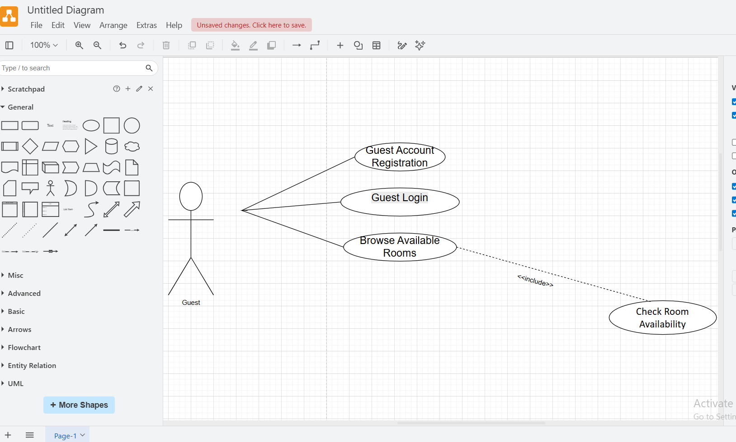

REQUIREMENTS
Functional Requirements

Req# | Requirement | Comments
FR_01 | The system shall allow a guest to register an account using full name, email, and password. | Email must be unique within the tenant.
FR_02 | The system shall allow a guest to log in using email and password. | JWT must include tenantId, userId, and role.
FR_03 | The system shall display available rooms including room type, price, description, and photos. | Listings are scoped to the hotel tenant.

Non-Functional Requirements
Req# | Requirement | Comments
NFR_01 | The system shall respond to user actions within 2 seconds. | Applies to login, browsing, filtering.
NFR_02 | The system shall ensure secure password storage using hashing. | Security requirement.
NFR_03 | The system shall use secure authentication via JWT. | Must include tenant context.

